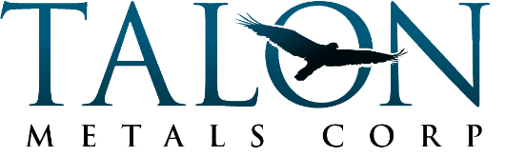
SUMMER INTERNSHIP APPLICATION

Please provide your responses to the application questions (below) and email to:
Breanne Johnson
bjohnson@talonmetals.com
Email subject line: “2024 Summer Internship Application”

Application deadline: April 26, 2024
Interviews will be held in May 2024

Application Questions:
- Please tell us about yourself, including your hobbies/interests:
- What are your future plans after graduating high school?
- What are your long-term career goals?
- Why are you interested in this internship with Talon?
- Why should we choose you for this position?
Please include your contact information including:
- Full Name
- Phone Number and/or Email Address

