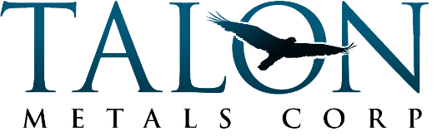
2022 SUMMER INTERNSHIP APPLICATION

Full Name:
Phone Number:
Email:

Application Questions:
- Please tell us about yourself, including your hobbies/interests:
- What are your future plans after graduating high school?
- What are your long-term career goals?
- Why are you interested in this internship with Talon?
- Why should we choose you for this position?

Please provide your responses to the application questions (above) on the following blank page, then email your completed application to:
Mindy Koen
koen@talonmetals.com
Email subject line: “2022 Summer Internship Application”

Application deadline: April 29, 2022

